**DAILY ONLINE ACTIVITIES SUMMARY**

|  |  |  |  |  |  |  |  |  |
| --- | --- | --- | --- | --- | --- | --- | --- | --- |
| **Date:** | **05-06-2020** | | | | | **Name:** | **SRILATHA K KAMATH** | |
| **Sem & Sec** | **6 B** | | | | | **USN:** | **4AL17CS099** | |
| **Online Test Summary** | | | | | | | | |
| **Subject** | | **1. Operations Research**  **2. Python Application Programming** | | | | | | |
| **Max. Marks** | | 1. **30** 2. **20** | | **Score** | | | 1. **30** 2. **16** | |
| **Certification Course Summary** | | | | | | | | |
| **Course** | **E box Online Classes** | | | | | | | |
| **Certificate Provider** | | | **Amphisoft** | | **Duration** | | | **1 ½ hours** |
| **Coding Challenges** | | | | | | | | |
| **Problem Statement:** Python programs to take in string and delete a character present a desired index and to square the odd elements in a given list. | | | | | | | | |
| **Status: COMPLETED** | | | | | | | | |
| **Uploaded the report in Github** | | | | | **YES** | | | |
| **If yes Repository name** | | | | | https://github.com/alvas-education-foundation/Srilatha-K-Kamath-Daily-Report.git | | | |
| **Uploaded the report in slack** | | | | | **YES** | | | |

Online Test Details:

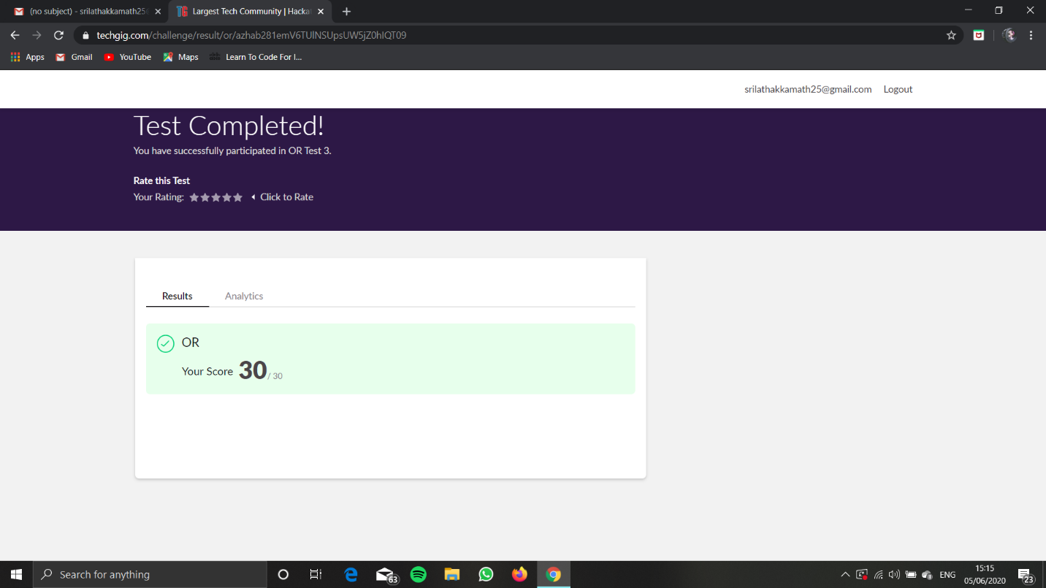

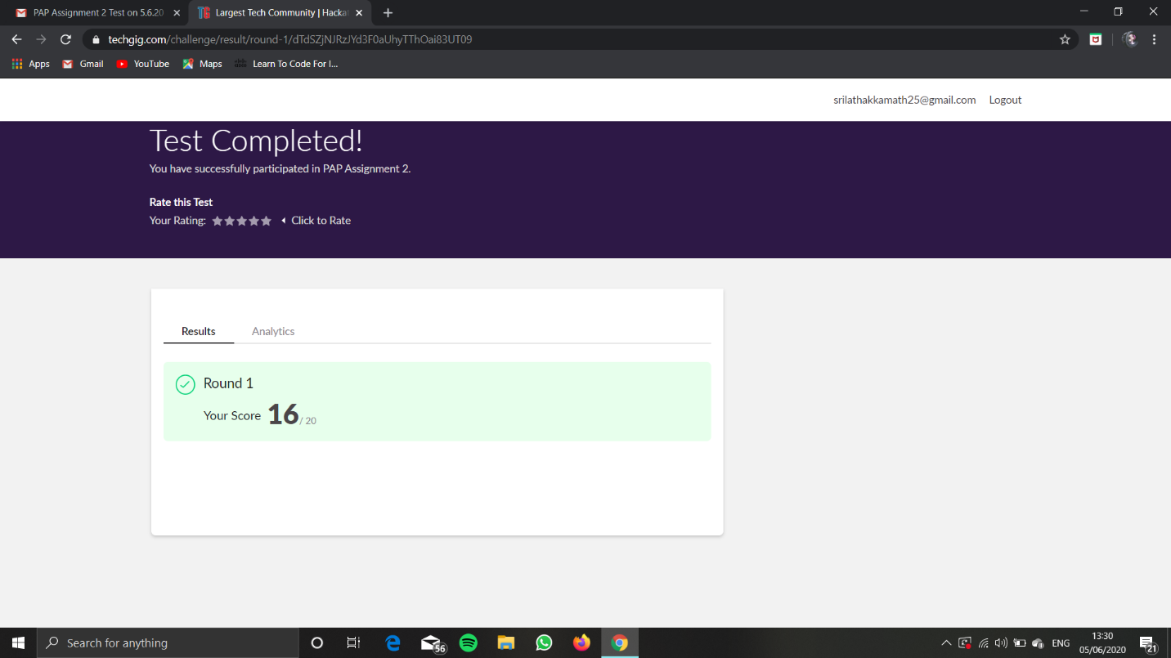

Online Course Details: Attended e-box zoom class on Python.

Topics taught:

Relationships between classes:

Association & Aggregation.

One to One, One to Many, Many to Many

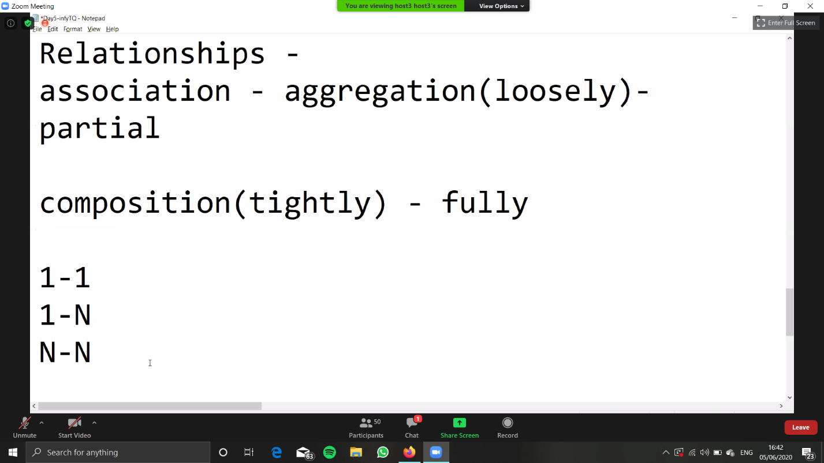

Some coding examples for the same topics. 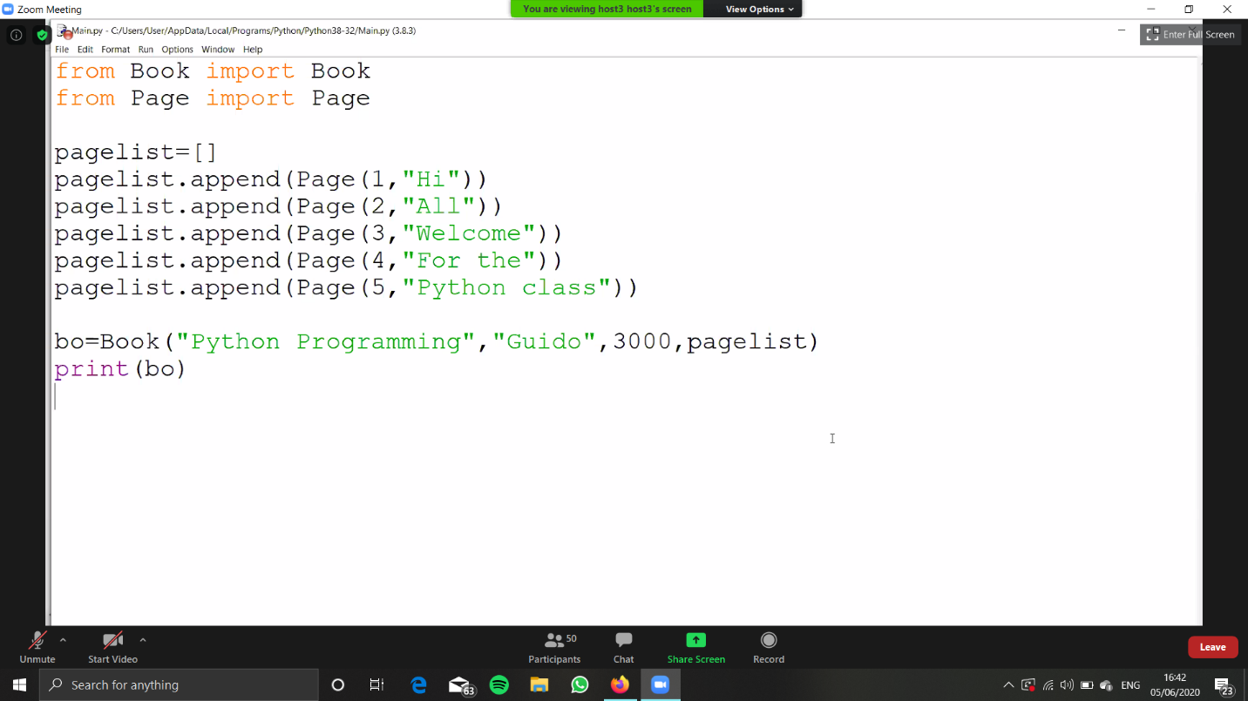

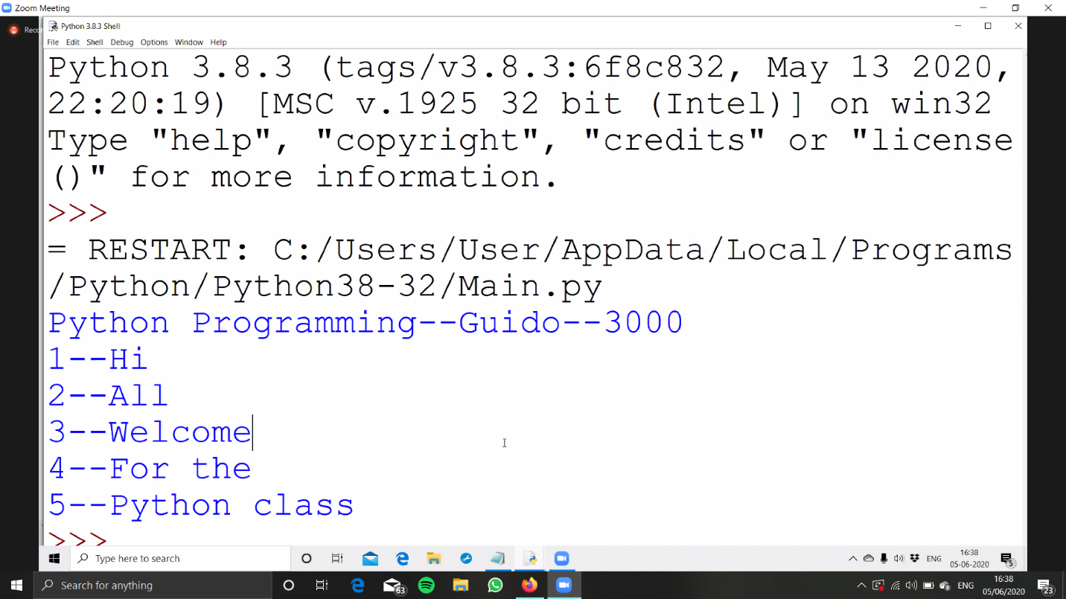

Online Coding Details: 2 Python programs

